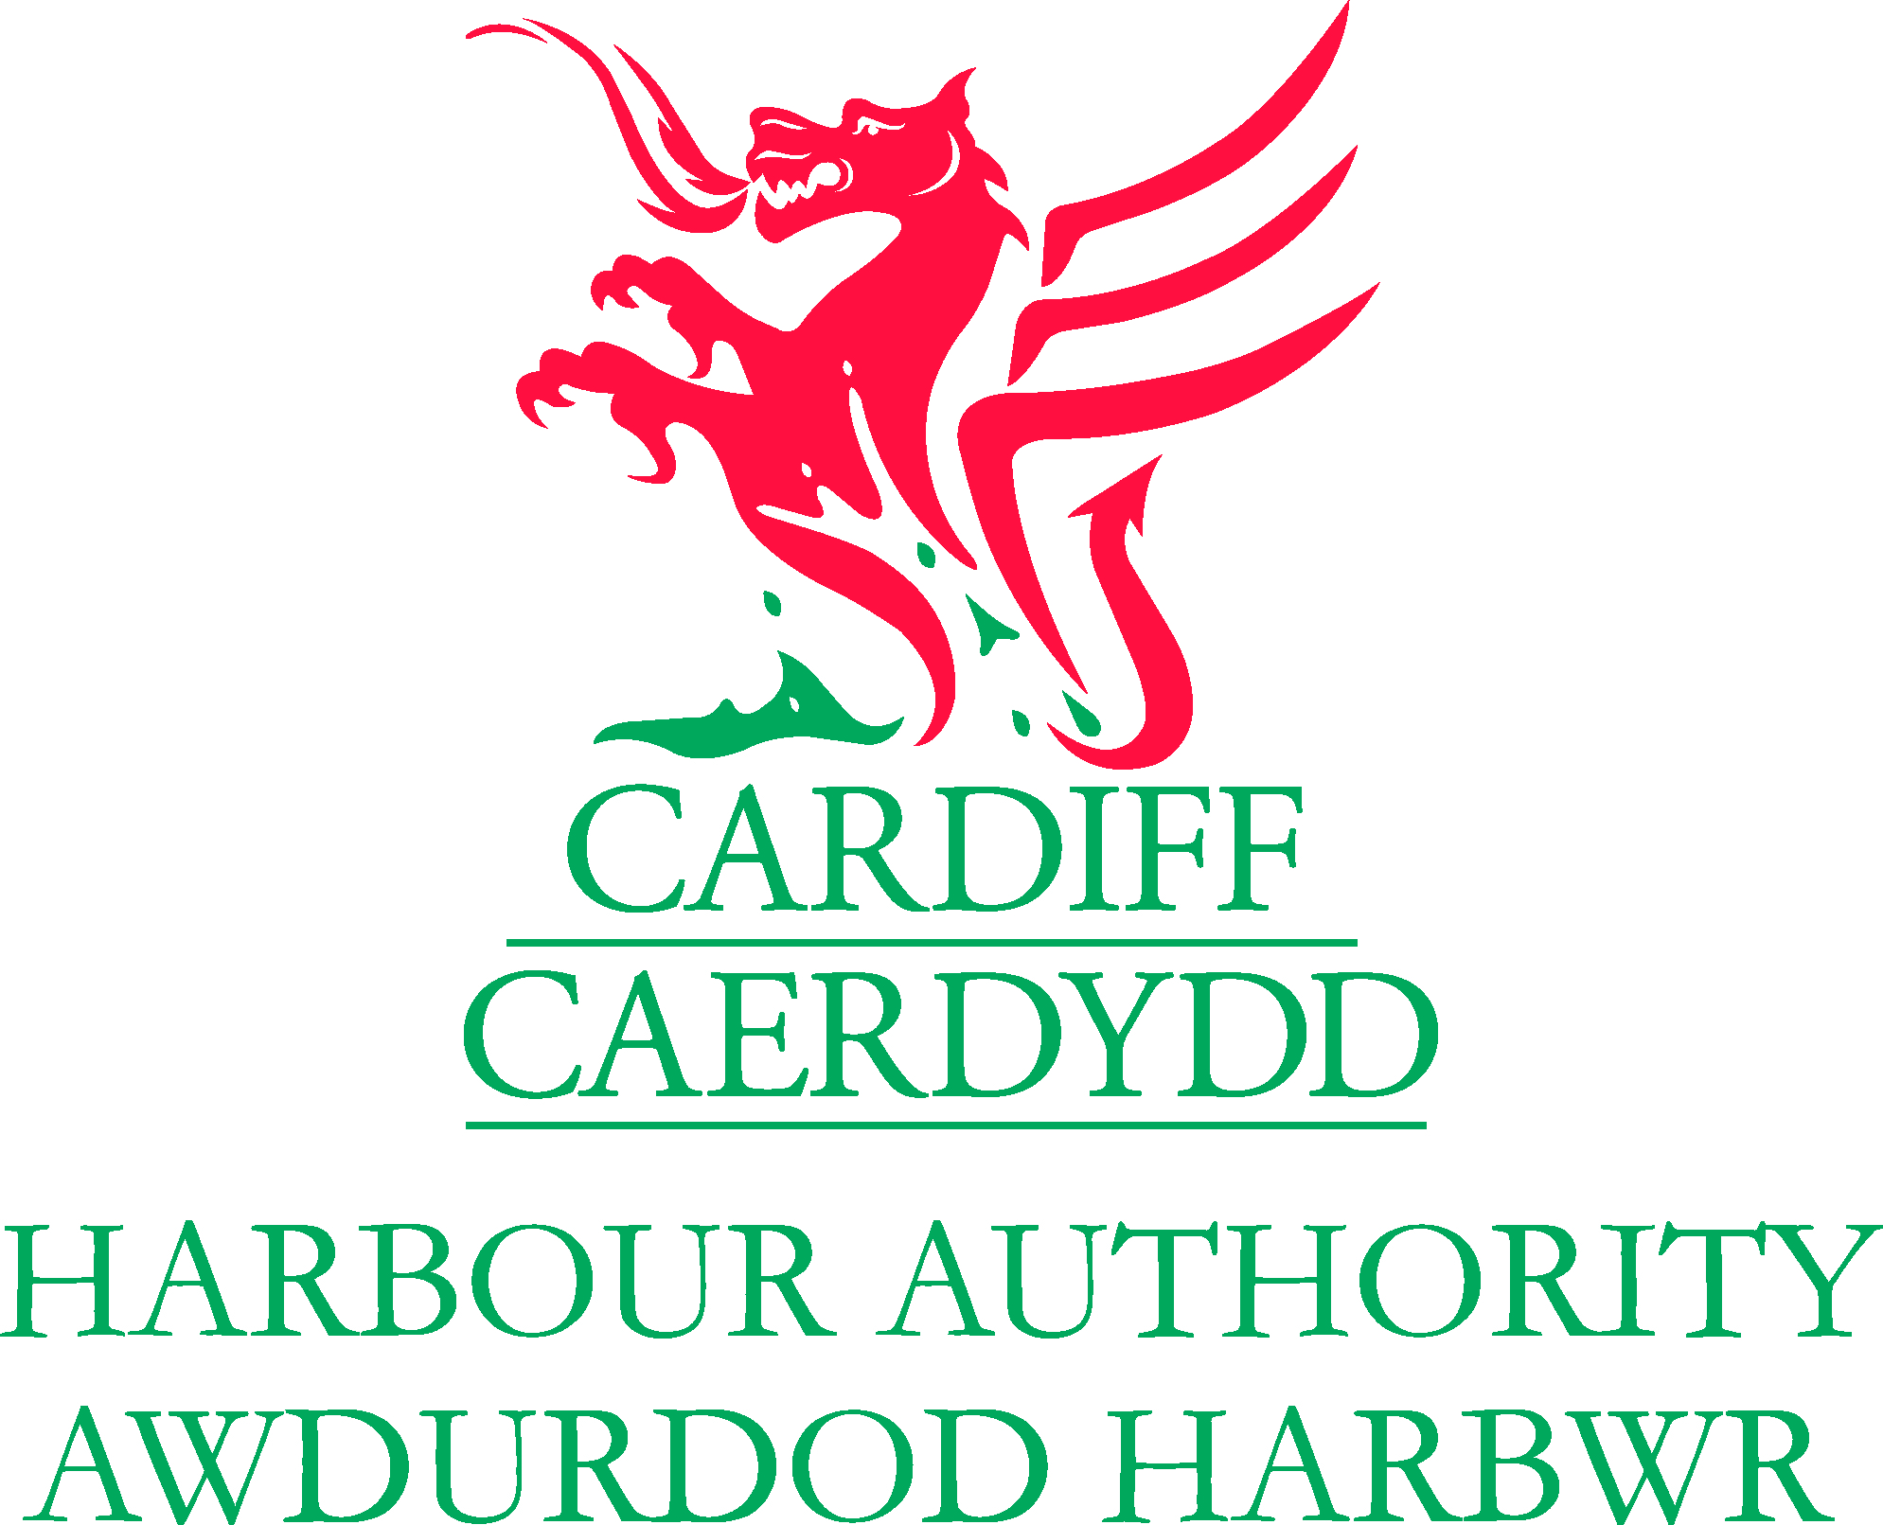

LOCAL NOTICE TO MARINERS

No 08 of 2021 – Water Ski Pilot Scheme / Zone

Mariners are reminded that a water ski pilot scheme continues to take place within Cardiff Bay (See attached plan).

When in use this water ski area will be delignated by a line of yellow pillar buoys. Mariners are requested to navigate with caution in the immediate area and keep clear of the exclusion zone during the following times. Paddle craft transiting between the Taff and Ely are to keep to the Bay edge and navigate within the Paddle craft transit route marked by yellow buoys on the attached plan.

Fridays - 1300hrs until 30 mins before sunset

Saturdays - 0800 hrs until 1230 hrs

Sundays - 1700 hrs until 30 mins before sunset

Mondays - 1300 hrs until 30 mins before sunset

Mariners are requested to keep clear of the exclusion zone and to navigate at slow speed in this area

Mariners are reminded that CCTV is in operation at the Barrage for operational and health and safety reasons. All CCTV images and VHF transmissions are recorded.

Notices Cancelled

No 03 of 2017 – Water Ski Pilot Scheme

Notices Remaining in Force

No. 14 of 2020 – PYW timetable Pilot scheme
No. 02 of 2021 – Lifting of Navigation Restrictions – (Staying Local during Covid 19)
No 04 of 2021 - Notice of Discontinuance of Aids to Navigation – Cardiff Barrage Approach Channel Sector Light and Taff Crossing Viaduct Upstream and Downstream lighted beacons
No 05 of 2021 – Temporary Exclusion Zone – Aquapark Cardiff
No 06 of 2021 – Welsh Rowing Time Trial – River Taff – Saturday 24th July 2021
No 07 of 2021 – Paddle craft transit route between River Taff and River Ely

For notices that remain in force prior to 2016 please see: www.cardiffharbour.com

Harbour Master, Cardiff Bay
16th July 2021
Queen Alexandra House, Cargo Rd, Cardiff, CF10 4LY
Barrage Control Tel No: 029 2070 0234, VHF18

